# Design description

# Solar Tracker v0.1

July 6, 2018

Gregory Fung

[gwfung@gmail.com](mailto:gwfung@gmail.com)

Solar Village, Tamera Healing Biotope

Colos, Portugal

Table of contents

**Design description** **1**

**Solar Tracker v0.1** **1**

**System Concept** **3**

Open source info 3

Development context 3

Block Diagram 4

Power supply concept 4

Assumptions 4

**Future improvements** **4**

**Usage Concept** **5**

Configuration for a particular application 5

Hardware interface and installation 5

Power supply 5

Motor connections 5

Limit switches 5

Sun sensor 5

Usage Scenarios 5

Manual placement on sun, automatic tracking 6

Automatic alignment to sun and tracking 6

Mode switch 6

Manual positioning 6

Setting RTC 7

**Hardware modules** **7**

Motor Control 7

DC-Motors 7

Stepper-Motor Drivers 8

Limit switches 8

User inputs 8

Mode switch 9

Manual control buttons 9

Connections 9

RTC 10

Sensor 11

Operation amplifiers 11

Arduino interface shield 11

Extra ground and RTC connection 12

**Firmware** **12**

Code layout 12

Application configuration 12

High-level control 12

Motor controller interface 12

Location estimation 12

LED Status indicator 13

Limit switches 13

RTC 13

Sun positioning 13

Helios celestial calculator 13

Alt-Az to fixed equatorial coordinate transform 13

Serial monitor debug output 13

# 

# System Concept

## Introduction

This Arduino controlled solar tracker is developed to allow more configuration and operation flexibility than the preexisting pure analog implementation.

See introduction / background document for more information

## Open source info

This project is published under CC0 license and thereby public domain. You are free to share, modify and use this these informations also for commercial purposes.

Check for more information: <https://creativecommons.org/publicdomain/>

## Development context

The tracker has been developed to work in various applications. For the first test, a prototype has been set up and tested with the Tamera-FixFocus Solar Concentrator, as a drop-in replacement for the existing analog controller.

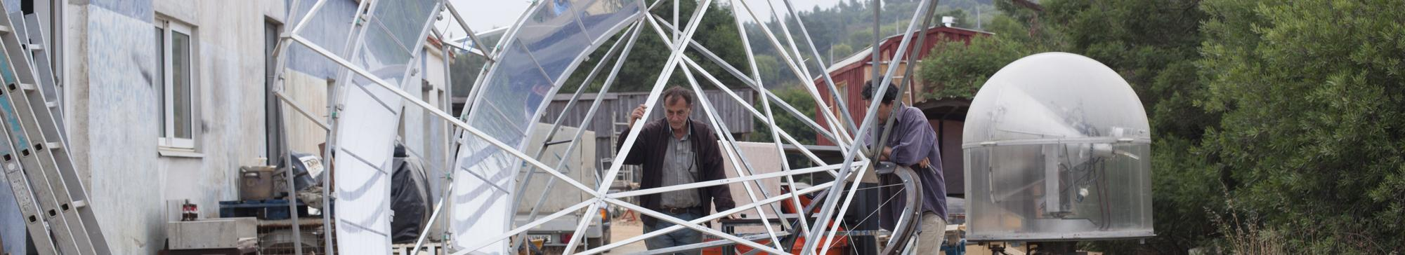

Test-setup: Tamera-FixFocus Solar Concentrator

## Block Diagram

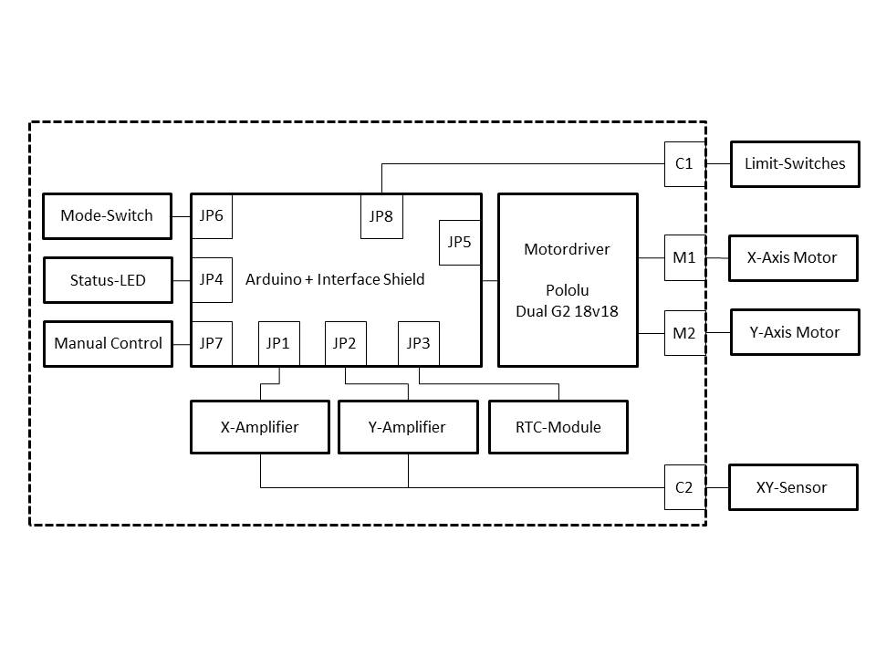

The power supply for the controller also supplies the motors, which is not shown in the diagram above.

## Project Assumptions

* for position estimate: Rectangular integration of motor setting over time
* limit switches do not open again even if overshooting on move
* for now, safe position is home position.
* future: arbitrary safe position support, change by time / season

## Acronyms

ADC Analog to digital converter

I²C I²C two-wire serial bus standard

RTC real time clock

## Status as of 07.07.2018

* The software v0.01 should be fully functional, with “TODO” in the source code marking possible improvements.
* The tinyRTC responds over I²C, but time keeping is very inaccurate. The hardware module should be replaced. Afterwards, see “Setting the RTC”
* HOME_POSITION_? for the Tamera fixed-focus are rough and should be more precisely configured.
* NORMAL_COMPUTATION_MS and EXTENDED_COMPUTATION_MS has not been measured and calibrated. However, rough values of MOTOR_SPEED_????_PER_SEC_? has been calibrated and should give halfway reasonable position estimates. These settings are dependent on the computation times above, the motor drive speed settings POLOLU_SPEED_????_?. More work is needed in this area.
* Sometimes during operation, the high motor currents being switched harshly on and off will cause the USB connection to be broken.

## Future improvements

* solar cooking controller:
  + Maximum temperature and cooking time regulation / control
* Logging of sensor levels, when closed-loop tracking, as a rough estimate of irradiation for analysis and potentially cooking power applications
* Ramping motor control outputs to reduce inrush currents
* Fault logging with time stamping for later diagnostics
* Magnetic compass to allow feedback about azimuth, for mobile applications
* Redesign sensor casing for 3D printing

# Usage Concept

## External of controller enclosure

### 

## Configuration for a particular application

Hardware configuration should be considered, to see if the motor controller can output sufficient current to drive the motors required.

Firmware configuration, to be done in the constant definitions at the beginning of the Arduino code file:

* Latitude / Longitude
* Whether the actuators are Alt-Az or equatorial mount
* Control deadbands for fast and slow movement, to reduce overshoot

## Hardware interfaces and installation

### Power supply

Supports input voltages in the range of 12-24V. The power supply must be sufficiently strong to power motors, even during inrush situations.

### Motor connections

X axis (M1) and Y axis (M2) motor outputs.

#### Polarity

Positive movement direction is defined to be numerically increasing direction for each control variable.

For alt-az mode, positive azimuth means clockwise movement of X, and positive altitude (elevation) means pointing higher in Y.

For stable equatorial coordinate mode, positive hour angle (tau) means clockwise movement of X, and positive declination means winter orientation for the northern hemisphere? in Y.

### Limit switches (C1)

Normally open or normally closed switches can be used to sense the limits. The switches should be built in in such a ways so that the mechanism cannot “overrun the switches”, reducing the lost of limit signal even though the mechanism is outside its range of movement.

### Sun sensor (C2)

The sun sensor is mounted on the mobile part of the array and wired to the control box. It should mounted so the two axis are aligned with the movement directions.

## Usage Scenarios

The decision not to have absolution position sensing of the mechanism means that a homing sequence may be required after power up, so that the controller knows roughly which way the mechanism is pointing. This takes some time, and the user is offered different ways to use the track to possibly avoid the homing sequence

### Manual placement on sun, automatic tracking

If the sun is strong enough, this usage mode avoids the need for a position calibration

1. Before power on, set the mode switch to IDLE
2. Power on the controller.
3. Use movement buttons to aim the sensor and mechanism towards the sun
4. If the status LED is blinking green, the sun sensor signal is strong enough for closed-loop sun tracking. If it is blinking yellow, the sun is too weak for closed-loop sun tracking.
5. Set the mode switch to TRACK.The LED should change to steady glowing.
   1. If it is green, closed-loop tracking is active, and the position is also now calibrated in the controller based on the calculated position of the sun at this time.
   2. If it is yellow, only open-loop positioning based on calculated sun location is currently possible.

### Automatic alignment to sun and tracking

1. Power on the controller.
2. After power on, when the mode switch is set TRACK first:
   1. And the sun sensor has enough signal, no homing sequence will be triggered. See the 1st use case above.
   2. And the sun sensor does not have enough signal, a homing sequence will be triggered. The mechanism will travel to the minimum positions in each axes until the limit switches are triggered.
3. After power on, if the mode switch is set to SAFE first:
   1. A homing sequence would be triggered, as above. After homing, the mechanism will travel to the appropriate safe position defined during controller configuration.
4. If the status LED is blinking green, the sun sensor signal is strong enough for closed-loop sun tracking. If it is blinking yellow, the sun is too weak for closed-loop sun tracking, and operating in open-loop mode if possible.

## User interface

The user interface is designed with simple intuitive operation in mind.

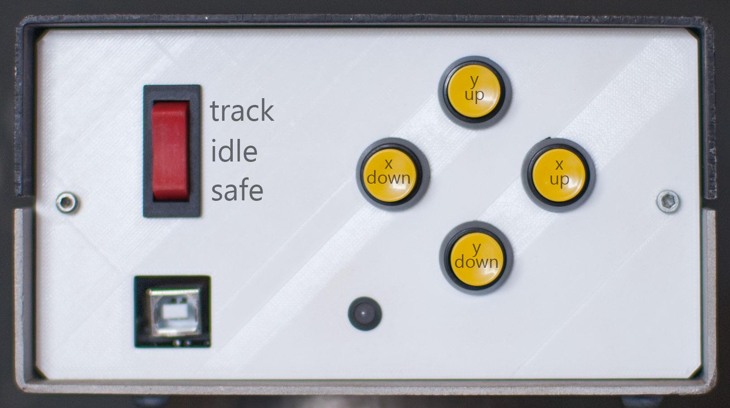

## Mode switch

Three different modes are available:

* Track: The solar tracker is active and automatically positions the mirror.
* Idle: The mirror can be positioned manually by using the control buttons..
* Safe: The mirror will be positioned automatically in the “safe-position”.

## Status indicator

The LED indicates:

* Green steady: Tracking active. Sensor can see the sun well.
* Green blinking: Tracking not active. Sensor can see the sun and we are ready to enter “closed-loop” mode, without performing homing movements.
* Yellow steady: Tracking active, and sensor cannot see the sun well. “Open-loop” operation.
* Yellow blinking: Tracking not active, and sensor cannot see the sun well.
* Red steady: user input or recoverable error. System is still at least partially functional.
  + May indicate error with the internal real time clock.
* Red blinking: system error, system not functional.

In summary: the color indicates in the sun can be seen. Steady means tracking, blinking means not tracking.

## Manual positioning

### Manual control buttons

Both axis can be controlled manually in idle-mode by using the push-buttons.

* X-Axis: Azimuth or hour-angle (ascension)
* Y-Axis: Elevation or declination

X down: move device in “lesser” X direction: azimuth or Hour angle

X up move device in “greater” X direction: azimuth or Hour angle

Y down: move device in “lesser” Y direction: elevation or array physically (declination)

Y up: move device in “greater” Y direction: elevation or array physically (declination)

Note: the polarity of the manual positioning buttons described above can be inverted using a setting in the Arduino code configuration. In some cases (eg declination in the northern hemisphere), it is more intuitive to have the Y+ button move the array up towards the most negative winter position.

## Setting RTC

To calculate proper position of the sun, the real time clock in the controller must be set to UTC time.

To set the real time clock inside the unit, only this roundabout way is currently support:

1. Set the time zone of the computer to UTC time.
2. Setup and Start the Arduino development environment on your computer.
3. Connect the Arduino to the computer using the USB interface.
4. Have a copy of the source code and all required libraries. See “Arduino development environment”
5. In the function setupRealTimeClock(), un-comment the line containing “rtc.adjust”
6. Connect to the Arduino using a USB connection.
7. Compile and upload the code.
8. On the first run, the Arduino would be set the RTC to the time of compilation.
9. Comment out the line in setupRealTimeClock() again.
10. Compile and upload the code, so that the rtc would not be set again on subsequent power-ups.
11. Unplug the USB connection

# Hardware Design

## Connections

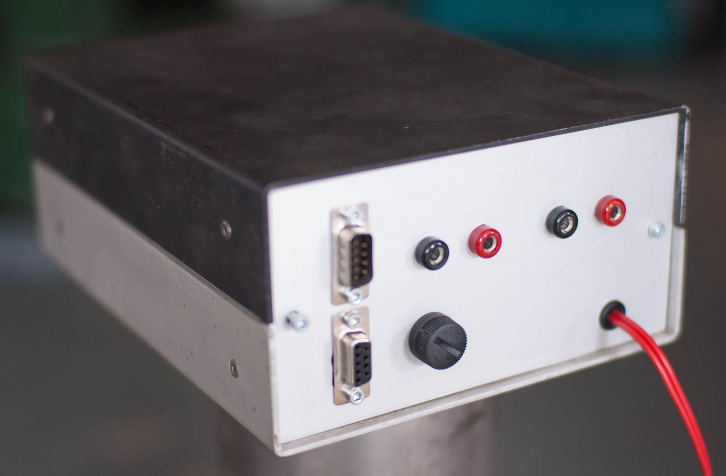

On the rear of the controller you find:

* Motor-connecters M1, M2 (4mm banana-plug: female)
* Limit switch input C1 (upper) DB9M
* Sensor input C2 (lower) DB9F
* Fuse: 10A, 20mm (slow blow)
* Power Input: 12V to 24V

## Power supply concept

From on the block diagram, the following devices need to be powered. The rest are powered by signals from the Arduino.

* Pololu Motor controller
* Arduino
* Sensor interface boards
* RTC

The system power supply is connected to VIN of the Pololu Motor Controller. It has a 7.5V regulator which supplies VIN of the Arduino. We also use unregulated but protected VM to supply +12V to the Sensor interface boards.

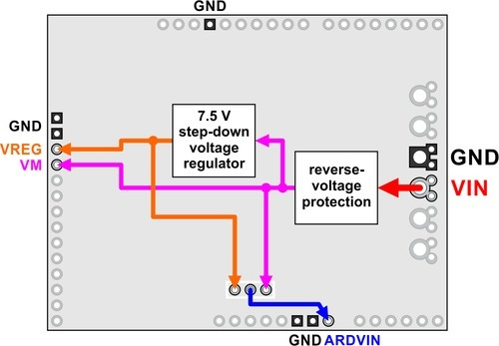

Power distribution concept in the Pololu Motor Controller shield

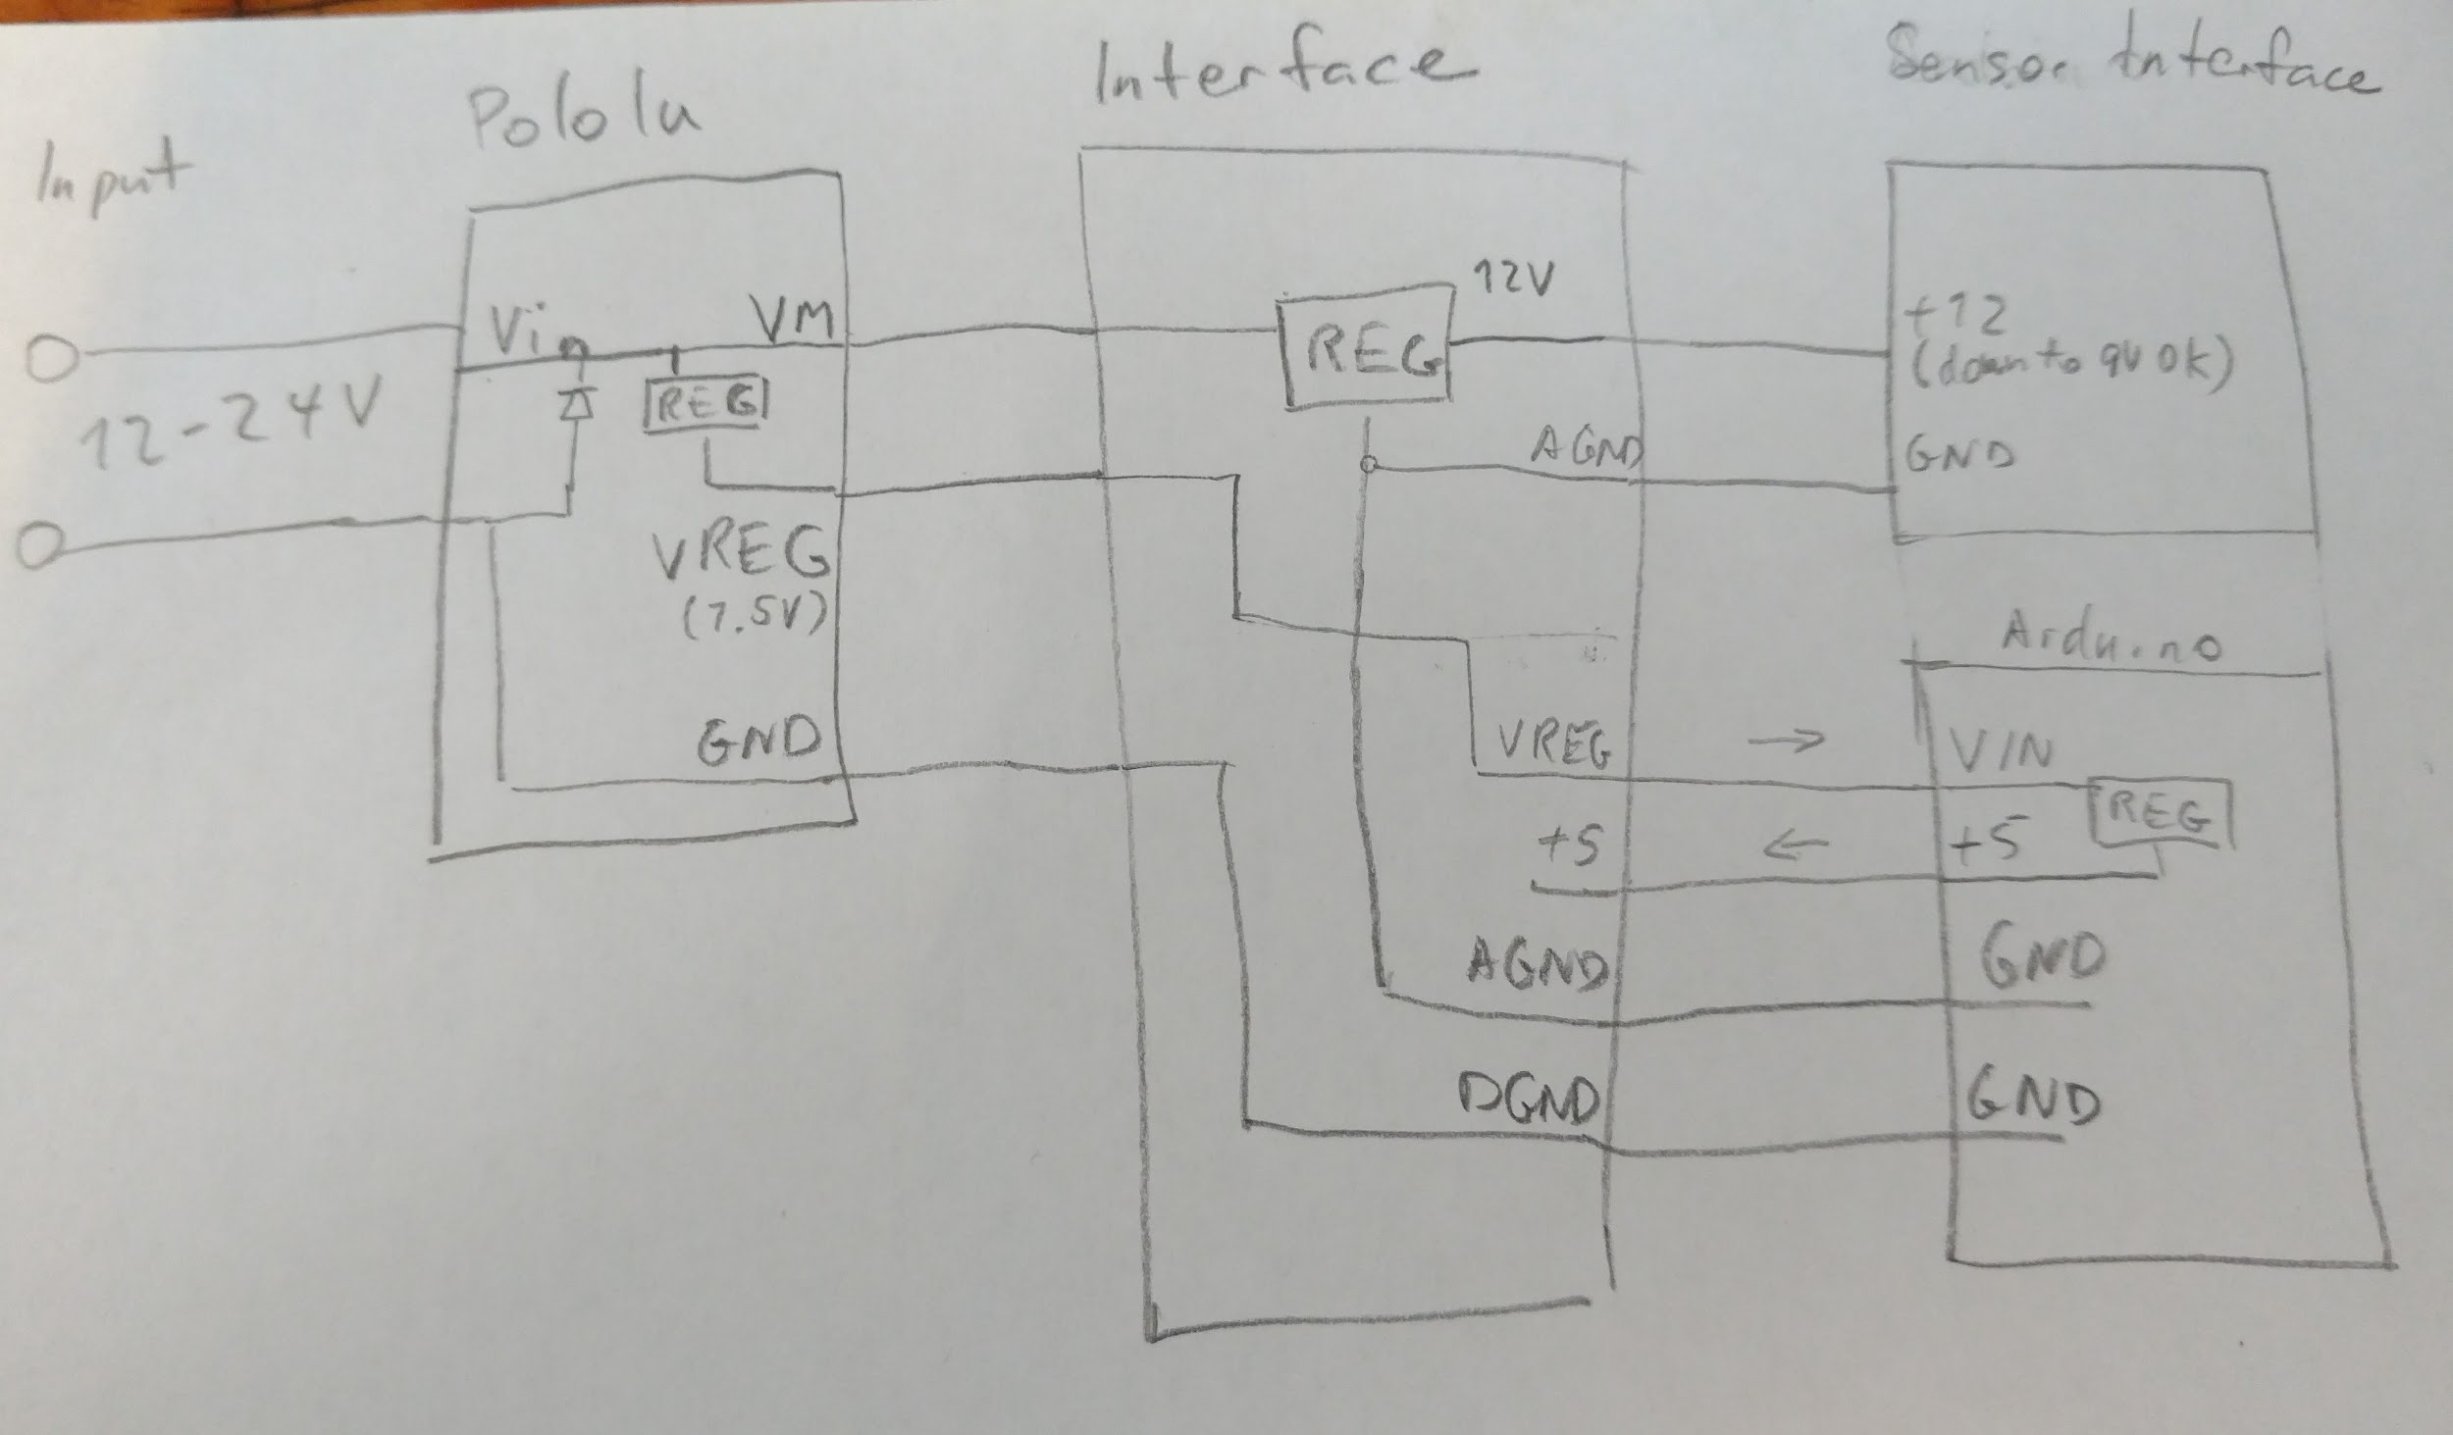

Power distribution concept of the solar tracker

The Arduino generates 5V using a regulator from its 7.5V VIN, and we use that to supply other logic like the RTC.

### System input voltage range and voltage headroom

In general, the system input voltage may vary between 12 to 24V.

As seen in the power distribution diagram, if the system input is 12V, the linear regulator on the interface shield will operate in saturation, meaning it can only achieve a voltage of around 9.5V. Therefore, the 12V input of the sensor interface is less than optimal. However, 9.5V is sufficient to power the required Op-Amps, allowing them to output up to 7.5V. Given the reference voltage of 5V, there is enough linear range for the output signals.

## Motor Control

The modular concept allows to use either stepper motors or DC-Motors. The motor-driver has to be selected to match you setup.

### DC-Motors

For DC-Motors, a dual high-power motor driver is used (Pololu Dual G2 18v18).

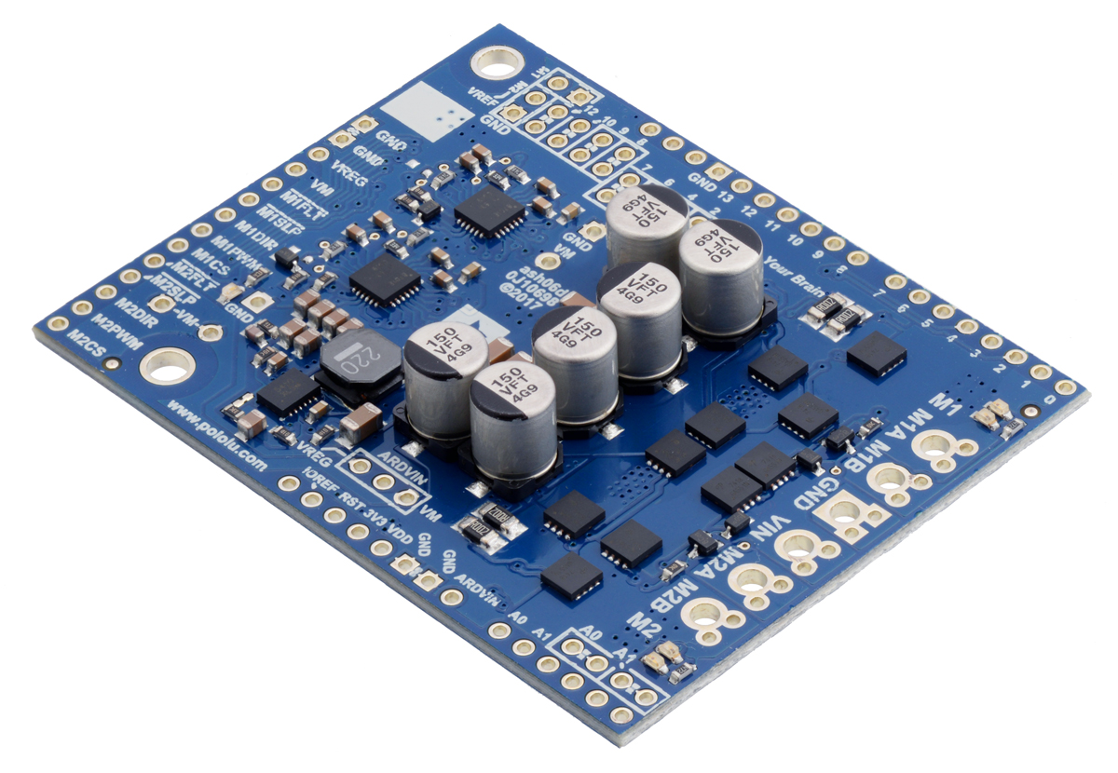

This driver can handle voltages of between 6.5V and 30V peak. Using 24V batteries is not recommended since they might be charged upt to high voltages close to max.

More information:<https://www.pololu.com/product/2515>

This driver includes a motor current reporting signal, which is sampled by the ADC channels of the Arduino.

A 14-pin cable connects the driver to the interface PCB. This cable was built using standard color coding (pin 1 is brown, 2 is red. etc)

### Stepper-Motor Drivers

This has not been full investigated, but theoretically, anything with a PWM and digital direction input can be used.

Suggestion:

* For small motors (Nema 17): DRV8852
* For big motors (Nema 23): TB6560

## Digital Inputs

For the limit switches, push buttons, and the mode rocker switch, one side of each switch is wired together for each function to ground. The internal 22k pull-up resistors of the Arduino is used, so that the signal voltage is high when the switches are open.

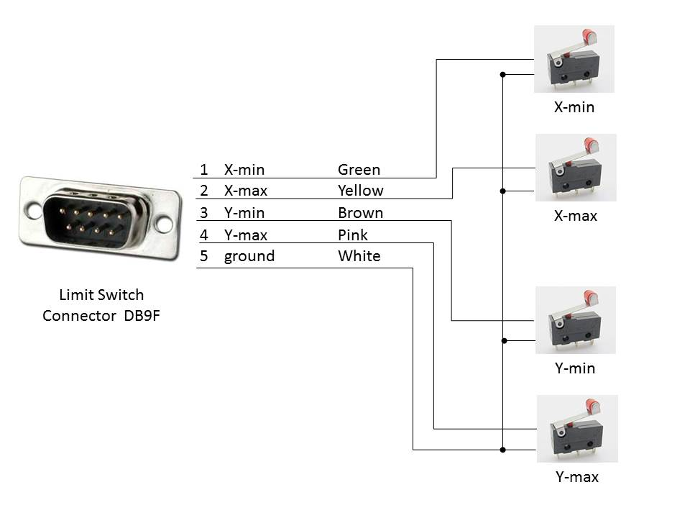

Wiring Harness “Limit-Switch”

## RTC

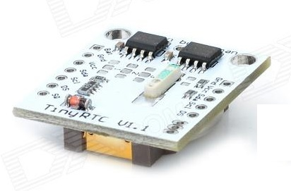

A basic RTC module (DS1307) is used to provide time and date. The coin cell (Type CR2032) keeps the clock running for several years.

The TinyRTC serves this and also includes a non-volatile EEPROM memory suitable for frequently changing data. It also supports a rechargable coin cell like LIR2032.

<https://www.elecrow.com/wiki/index.php?title=Tiny_RTC>

Arduino-Library: <https://github.com/adafruit/RTClib>

Where to buy: <https://www.ptrobotics.com/rtc/4791-funduino-rtc.html>

## Sensors

For position-feedback, a two axis sun sensor is used. The setup is fairly simple: For each axis, two photodiodes (Osram SFH 203 P) are placed close to each other pointing in the same direction. In between the four photodiodes (two for each axis with the connecting line of the two photodiodes of one channel being perpendicular to the one for the other channel) a block is placed that may create a shadow on some diodes if the sensor is not pointing straight at the sun.

## 

Sun Sensor with four photodiodes and block

Datasheet of the Photodiodes can be downloaded here TODO?

CAD drawings for the casing can be downloaded here

## Sensor signal conditioning

In the v0.1 prototype, existing 1-axis control boards (with mixed TH/SMD technology) were used. A cable was soldered onto 6 nodes and wired to the interface shield.

The two axes of the sun sensor are connected to the 2 control boards as shown. Each axis has a 3-pin polarized molex connector, which connects to X2-3, X2-4 and X2-5 as seen in the schematic which follows.

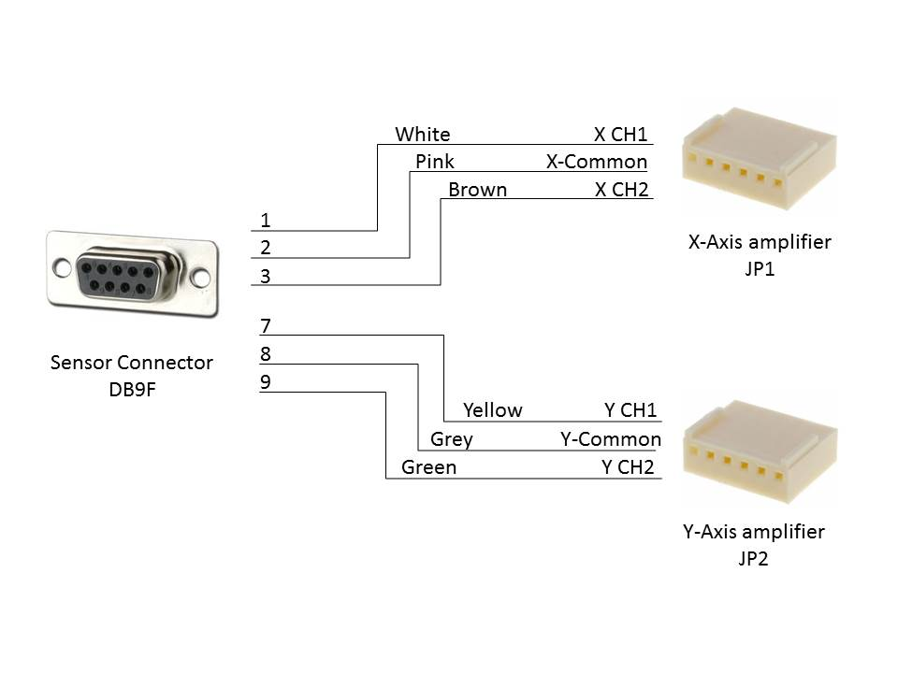

Wire Harness for Sensor

Each solar photodiode is connected to a transimpedance amplifier, and the difference is amplified as well. All 3 of these signals, as well as the 5V analog reference level, are sampled by the analog to digital converter of the Arduino, after being divided by 2.

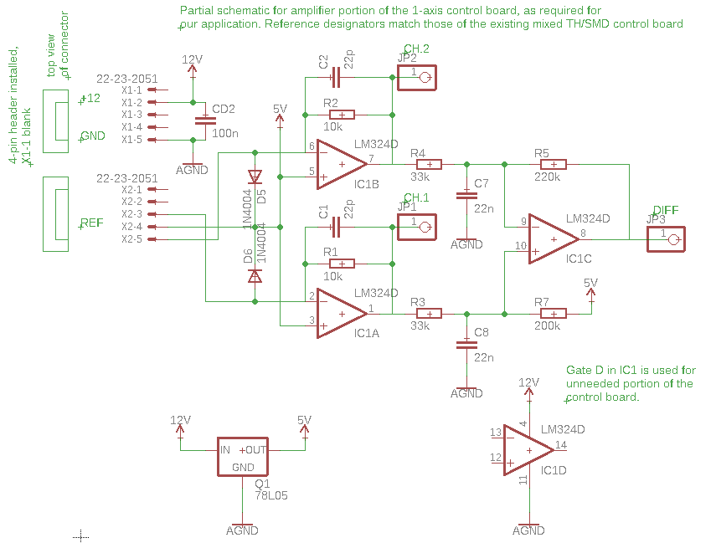

Schematic for used analog portion of the 1-axis control board

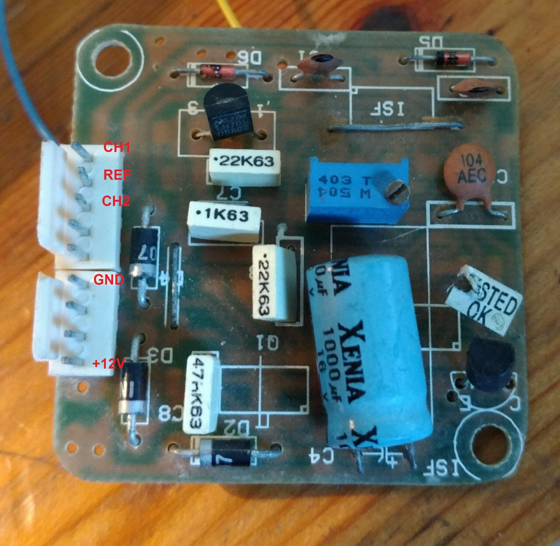 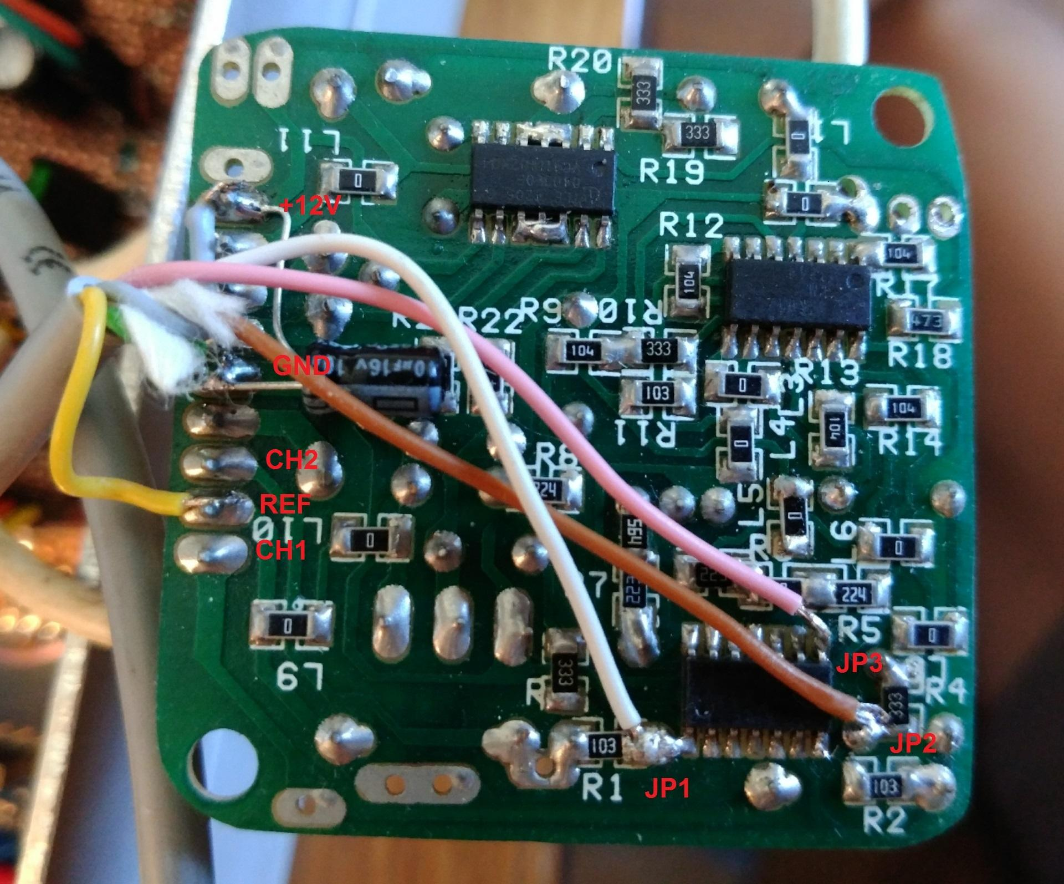

1 axis control board, with cable connections

The control board expects a 12V supply input, and used the 5V output from a voltage regulator as signal bias level. The +12V bus may be lower than 12V in the power concept, which is OK. See the description in the Arduino interface shield.

As our application does not require power supply at 5V, this should be replaced with a bandgap reference for better stability in the next design. This reference can also be used as the reference of the ADC on the Arduino.

For improved stability, a 10uF 16V electrolytic capacitor was added between +12V and GND under the board at the pin header to decouple the power supply locally.

The 6 signals (see in green in the schematic) are, in the pin order of the connector on the Interface Shield:

1. Channel 1
2. Channel 2
3. Difference signal
4. Reference signal
5. Ground
6. +12V supply

## Arduino interface shield

The interface-shield (through-hole pcb) is plugged on top of the arduino mega. It is used for:

* Break-out and connection: It provides discrete connectors to the different hardware functional blocks
* Power supply: A linear voltage regulator (7812) is used to regulate the input voltage (12V-24V) to stable 12V power for the arduino. With lower input voltages, It is acceptable that the regulator dropout voltage results in possibly only 9.5V on +12V bus. This is only used by the sensor interface boards. The LM324 are supplied by +12V; meaning possible positive saturation voltage of 9.5V - 2V = 7.5V. Working with a 5V bias, this is enough linear range.
* Signal conditioning: Voltage dividers are used to match the Op-Amp output to the arduino’s AD-range. These resistors are also placed on the shield.

|  |  |
| --- | --- |
| Interface-shield, top view (connectors) | Interface-shield, bottom view (to Arduino) |

In general, pin 1 of each connector is marked on the board with a green dot with a marker. The cables were also built with pin 1 marked using tape.

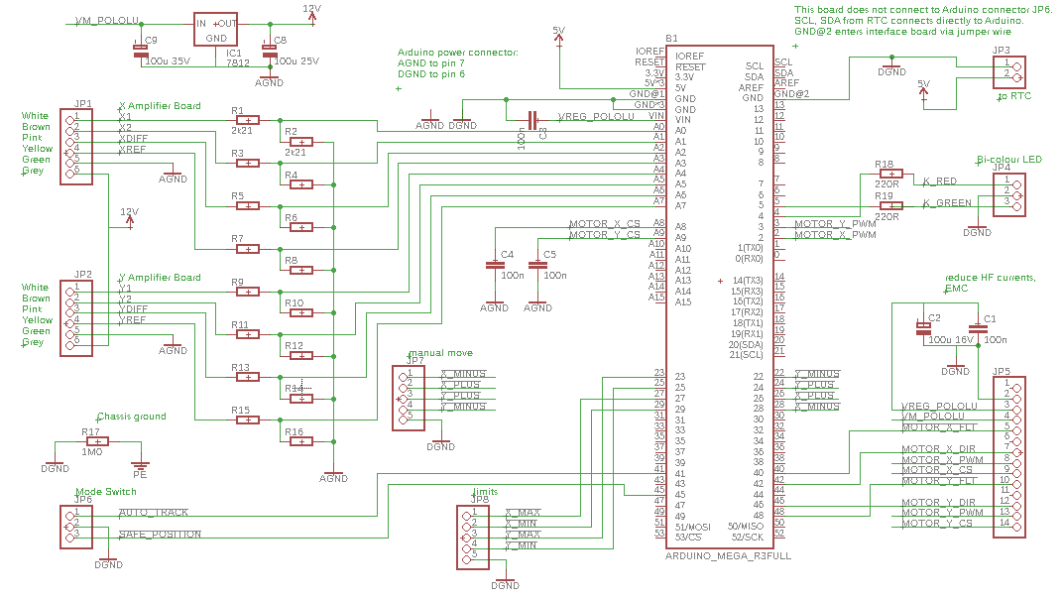

The prototype was built by hand using 1-sided protoboard using point to point wiring. Where possible, colour coding was used for the different connectors. Because connectors were needed on the top and bottom, it was difficult only having cooper on one side. I recommend 2-sided protoboard at least or a prototyping shield for the Arduino Mega.

### Extra ground and RTC connection

Due to the placement of JP6 off of the main 0.1” grid, I build the prototype shield without a connection to JP6 on the Arduino. Therefore, the I2C wire interface must be directly connected to the Arduino:

TODO add photo of connection from RTC to shield / Arduino

SCL directly to Arduino JP6 pin 1

SDA directly to Arduino JP6 pin 2

Vcc and GND to JP3 on interface shield: pin 1: GND, pin 2: VCC

There is also a wire and pin for DGND from the shield that connects to JP6 pin 4. There are multiple ground connections from the shield to the Arduino to reduce loop areas of current traveling around the board, to improve EMC performance.

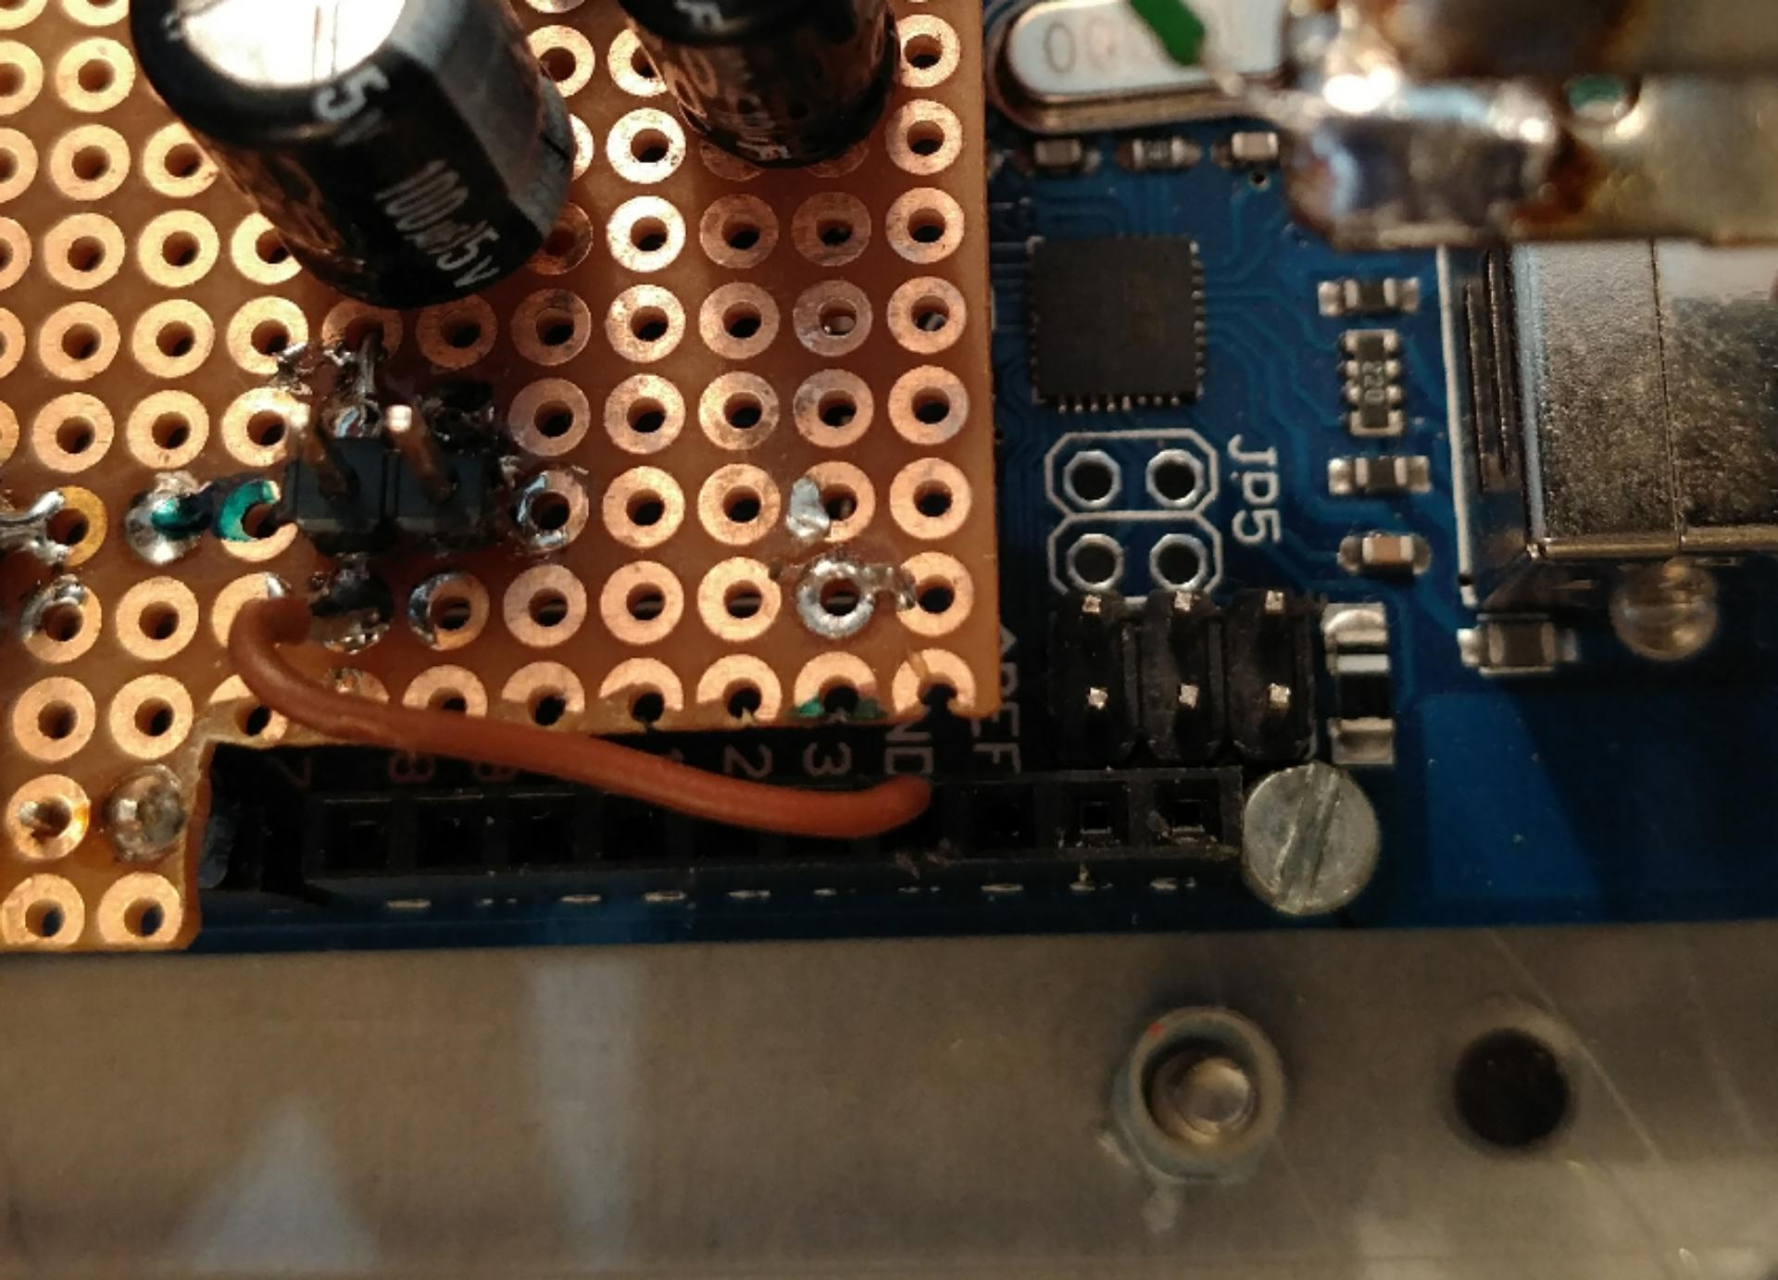

# Firmware internals

## Source Code

Latest version published here on Github:

<https://github.com/gwfung/Ardy-Solar-Tracker>

The initial version tested on 07.07.2018 is tagged v0.1

<https://github.com/gwfung/Ardy-Solar-Tracker/releases/tag/v0.01>

The Arduino project to open is called tracker_main.ino

## Development Environment

Tested on:

Arduino IDE 1.85

Libraries updated on 30.6.2018

Please see here on how to install and manage libraries,

<https://www.arduino.cc/en/guide/libraries>

## Required libraries

Dual-g2-high-power-motor-shield-master

<https://github.com/pololu/dual-g2-high-power-motor-shield/>

Helios

<http://wiki.happylab.at/w/Solar_Arduino_tracker>

RTC

<https://github.com/adafruit/RTClib>

## Code layout

Due to expediency and lack of experience with the Arduino IDE, currently the entire program is in one big .ino file, although the logical blocks are clearly divided. It would be nicer to split into different files.

## Application configuration

Almost all system-level configurations (such as location, actuator speeds and control parameters) are at the beginning of tracker_main.ino. Some items below to submodules, such as the speed constants used by the Pololu Motor controller, and are therefore in that section of the code.

The serial monitor sends out information about the internal state regularly, and there is a lot of debug output code “Serial.print(“abc”)” commented out. They can be useful to activate for debugging and monitoring during commissioning via the USB port and the Arduino IDE. “See Serial monitor debug output”

## High-level application

setup()

Initialization loops

loop()

## Control system concept

Open-loop: a position estimator runs in the software, as initialized by the homing movements at the limit switches, or by sun tracking lock and calculated sun location.

Closed-loop: a simple control error is calculated in ADC units. If the error is greater than the fast movement deadband, fast movement is used to attempt to reduce the error. If the error is less than the fast movement deadband but greater than the slow movement control deadband, slow movement is used to control the position more accurately. Note that the ADC SW filtering introduces delay in the error signal and can lead to overshoot and hunting if the slow movement is set too fast, or the fast movement deadband is too small.

Here are some key state variables used in the Firmware:

* “trackingActive”: whether sun tracking mode is active. Based on user input and current sensor conditions.
* “targetLocation”: the coordinates in alt-az or hour angle - declination where the array shoudl be aimed.
* “actualLocation”: the coordinates in alt-az or hour angle - declination where the array is currently being pointed.

## Fault handling

General fault mode

A general fault can be flagged when sensors or actuators behave unexpectedly. It will require a controller restart to clear the condition.

Closed Loop fault X and Y

Closed Loop fault is flagged if the closed loop tracking leads the array to point in a very different direction as what is expected by the open loop calculation. It may be due to a sensor fault, or there is another bright object / source stimulating the sensor.

RTC error

If there is an RTC error, open loop mode cannot function, but closed loop mode should function.

## Motor controller interface

The Arduino library for the Pololu motor controller can be found here.

<https://github.com/pololu/dual-g2-high-power-motor-shield/>

The only difference between the generic type DualG2HighPowerMotorShield and the model specific DualG2HighPowerMotorShield18v18 type is the encapsulation of the gains for the motor current sensing, which is different between different models of the shield.

The motor current is sampled, and a simple error threshold is implemented. If the maximum current is exceeded, the controller goes into general fault mode.

## Location estimation

To allow absolute aiming without position feedback sensors, an estimator is needed. A very rough one is implemented based on rectangular integration of the motor control speed command and the measured duration of the scan loops. From listening to the fixed-focus array, we can already hear that there is an acceleration and deceleration ramp, so this should be improved. Much better would be absolute or relative movement encoders, depending on whether the application has a fixed or mobile base.

## 

## LED Status indicator

Red and green are native LED colours. Yellow is supported using a PWM blending of those two colours.

setStatusLed() deals with the logical meaning of the status indicator.

ledStateUpdate() updates the blinking of the LED, and it calls writeBiColourLedPins to actually write the desired PWM values to the outputs.

The blinking is serviced regularly based on the CPU tick.

## Limit switches

Supports configuration for normally open or normally closed.

## RTC

Library

<https://github.com/adafruit/RTClib>

## Sun positioning

### Helios celestial calculator

<http://wiki.happylab.at/w/Solar_Arduino_tracker>

Version “SolarTracker4Arduino1.0.1.zip” was used to calculate Alt-Az based on location and time.

### Alt-Az to fixed equatorial coordinate transform

The fixed equatorial coordinate transform as described by the german Wiki page for Astronomical Coordinate system was implemented and tested, but with seemingly incorrect results. The function convertToStableEquatorialAxes_DEAD_CODE() remains in the source code.

convertToStableEquatorialAxes() was implemented based on another reference and tested OK. After taking arcsin, it is necessary to check and correct which quadrant in the plane the result landed in.

The valid range for hour angle was defined to be -180 to 180, so that there are no discontinuous jumps during the tracking day (0° at noon).

## Serial monitor debug output

The serial monitor is set for 115200bps, please set the Arduino IDE to match. The format of the result allows easy copy and pasting into a CSV text file for analysis with spreadsheet programs, using “,” as the field delimiter. “.” are used for decimals values.

Typical debug output lines:

17:23:19, Sun at Azi 274.15, Elev 27.70,| in fixed Equatorial: delta 19.58deg, H tau 69.60deg

X,863,71, Diff,-2030, Ok,1 | Y,62,883, Diff,2045, Ok,1,| trackON,1, 17:23:19, target X,69.60, Y,19.58, Pos X,0.00, Y,-0.23,| MotorCmd X,0, Y,0,| MotorI X,0, Y,0; CLActive X,1; Y,1; Faults: gen,0, CLX,0, CLY,0

X,865,71, Diff,-2030, Ok,1 | Y,62,884, Diff,2044, Ok,1,| trackON,1, 17:23:19, target X,69.60, Y,19.58, Pos X,0.16, Y,-0.16,| MotorCmd X,2, Y,2,| MotorI X,2928, Y,3172; CLActive X,1; Y,1; Faults: gen,0, CLX,0, CLY,0

…

X,833,825, Diff,-44, Ok,1 | Y,846,843, Diff,0, Ok,1,| trackON,1, 17:25:10, target X,70.05, Y,19.58, Pos X,70.05, Y,19.58,| MotorCmd X,0, Y,0,| MotorI X,0, Y,0; CLActive X,1; Y,1; Faults: gen,0, CLX,0, CLY,0

X,833,824, Diff,-51, Ok,1 | Y,847,843, Diff,-2, Ok,1,| trackON,1, 17:25:10, target X,70.05, Y,19.58, Pos X,70.11, Y,19.58,| MotorCmd X,1, Y,0,| MotorI X,0, Y,0; CLActive X,1; Y,1; Faults: gen,0, CLX,0, CLY,0

# Appendix

## Schematics for older sensor board designs

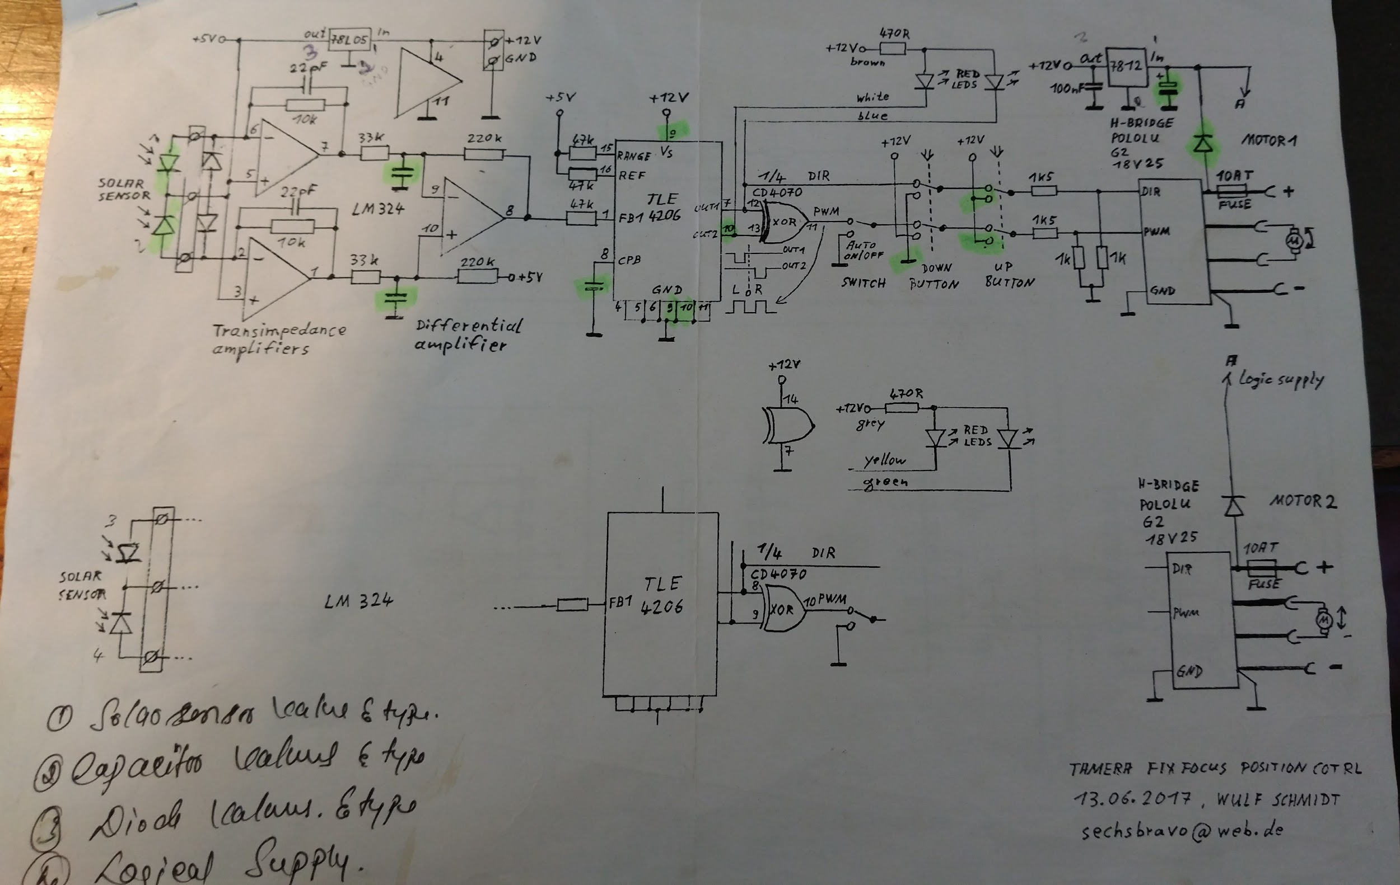

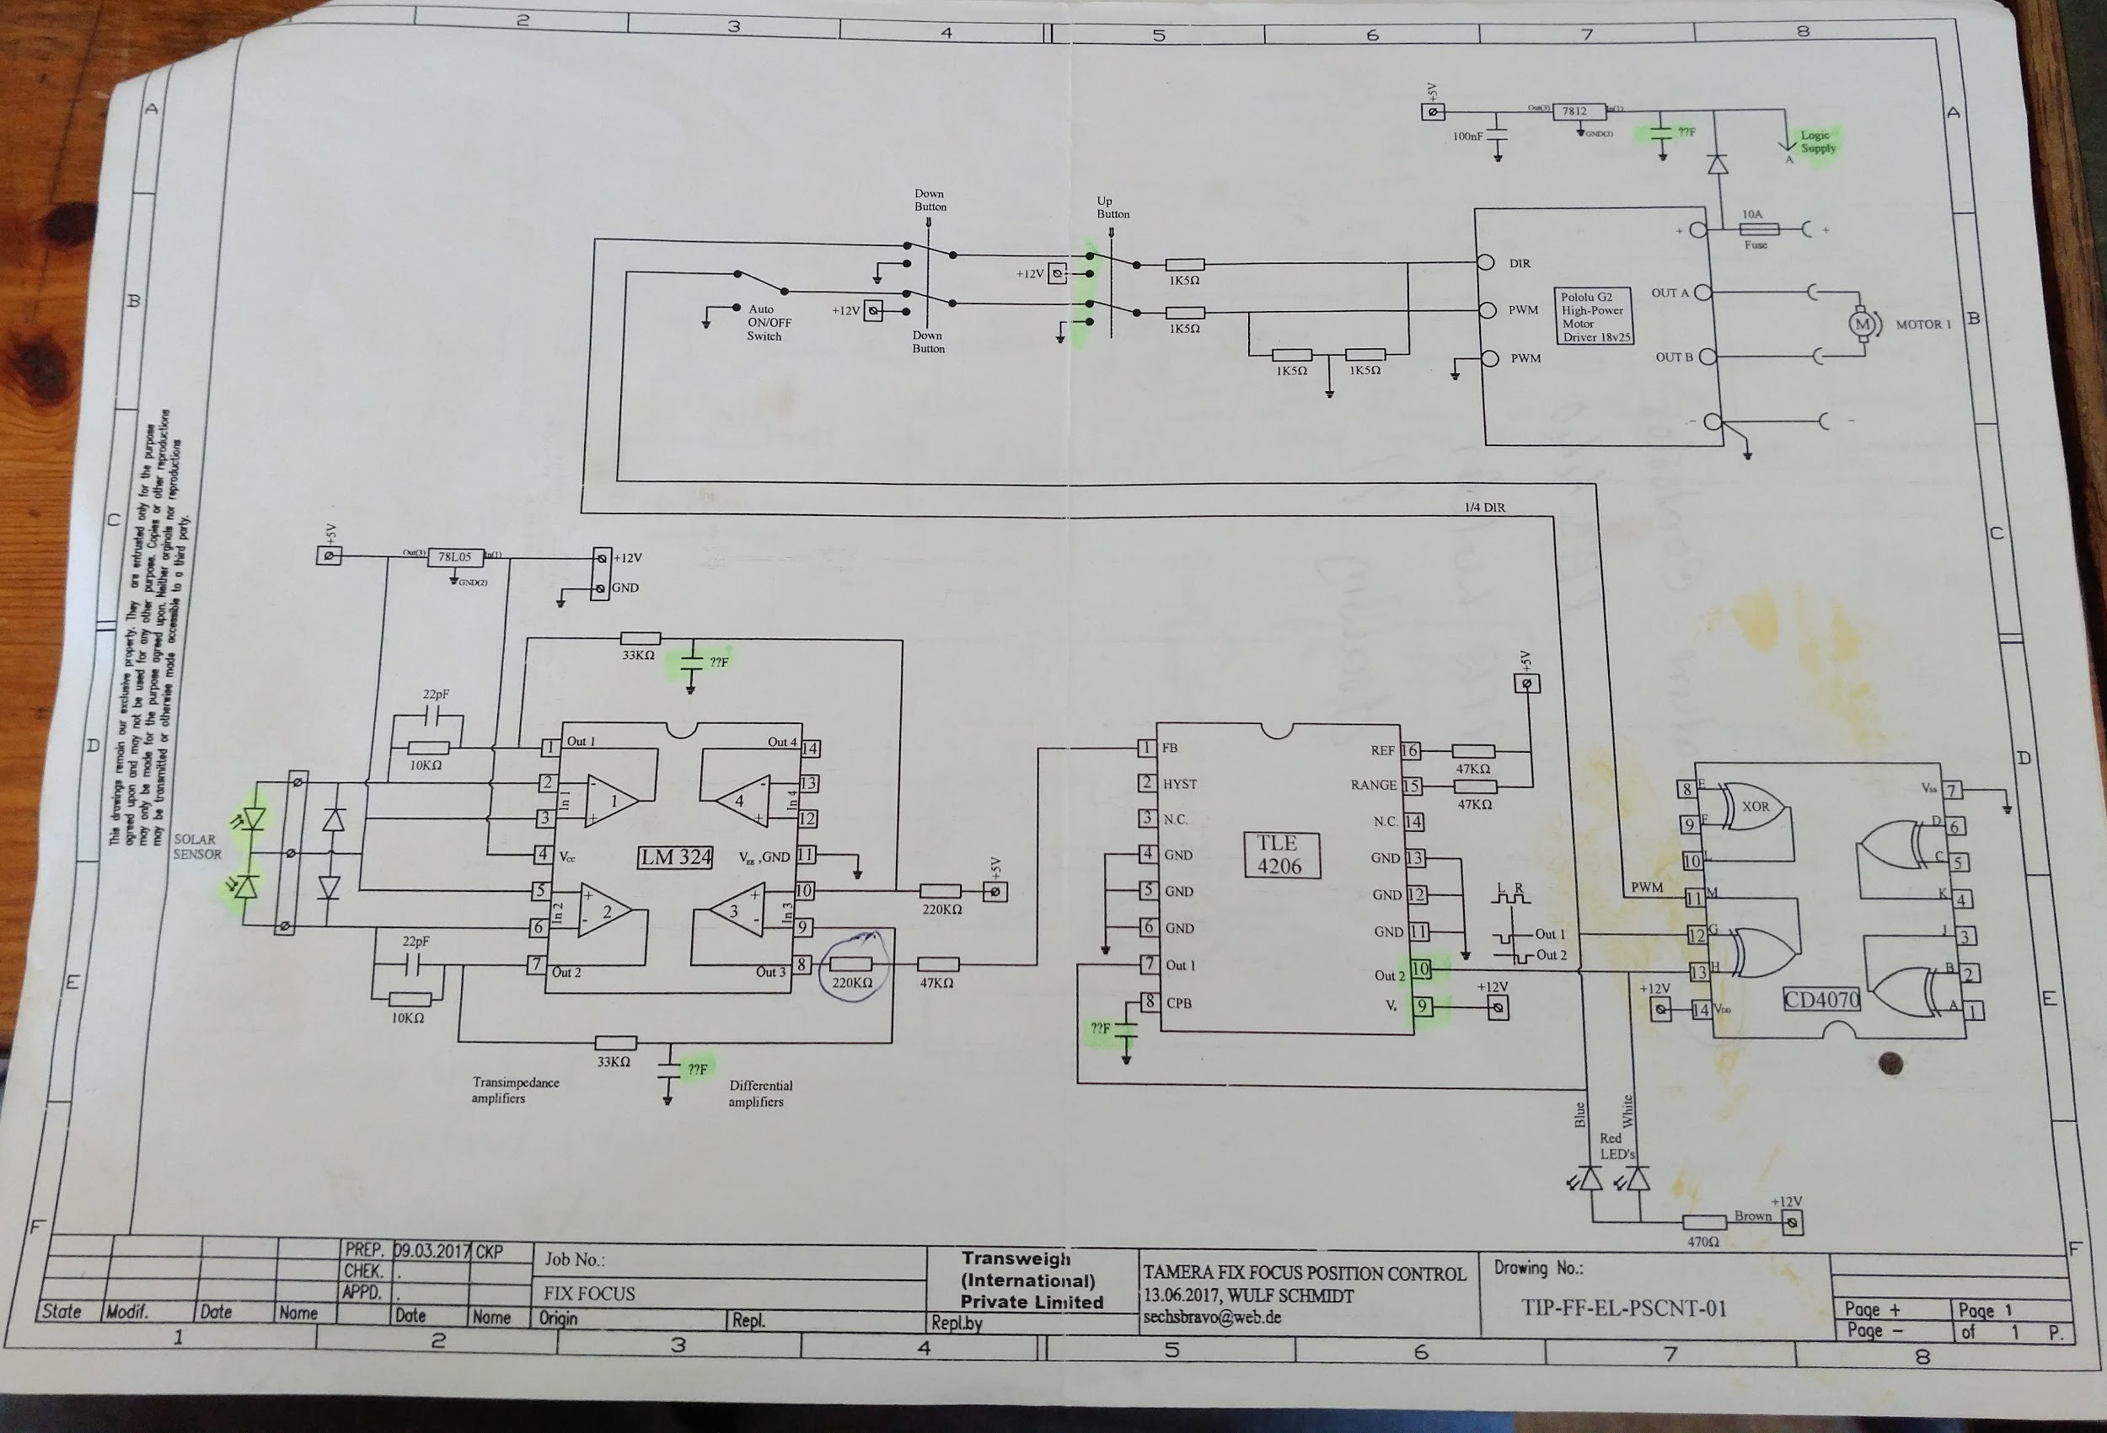

## Test results for convertToStableEquatorialAxes

Given time and location of Tamera, Az, Elev, H (tau) and delta were calculated in the test routine sunCalcTest(). Here are the results:

Time 2018/7/7 7:37:58  
0:0:58, Az:347.97, Elev:-31.63,| lat_RAD 0.66, azi_RAD 6.07, elev_RAD -0.55,| sin_delta 0.34, cos_delta 0.94, delta_RAD 0.34, sin_H 0.19, cos_H_num -0.73, cos_H -0.98, delta 19.74deg, H tau 169.14deg, targetPosition X169.14 Y19.74  
0:20:58, Az:353.45, Elev:-32.27,| lat_RAD 0.66, azi_RAD 6.17, elev_RAD -0.56,| sin_delta 0.34, cos_delta 0.94, delta_RAD 0.34, sin_H 0.10, cos_H_num -0.74, cos_H -0.99, delta 19.74deg, H tau 174.12deg, targetPosition X174.12 Y19.74  
0:40:58, Az:359.11, Elev:-32.53,| lat_RAD 0.66, azi_RAD 6.27, elev_RAD -0.57,| sin_delta 0.34, cos_delta 0.94, delta_RAD 0.34, sin_H 0.01, cos_H_num -0.74, cos_H -1.00, delta 19.74deg, H tau 179.21deg, targetPosition X179.21 Y19.74  
1:0:58, Az:4.54, Elev:-32.42,| lat_RAD 0.66, azi_RAD 0.08, elev_RAD -0.57,| sin_delta 0.34, cos_delta 0.94, delta_RAD 0.34, sin_H -0.07, cos_H_num -0.74, cos_H -1.00, delta 19.73deg, H tau -175.93deg, targetPosition X-175.93 Y19.73  
1:20:58, Az:10.11, Elev:-31.91,| lat_RAD 0.66, azi_RAD 0.18, elev_RAD -0.56,| sin_delta 0.34, cos_delta 0.94, delta_RAD 0.34, sin_H -0.16, cos_H_num -0.74, cos_H -0.99, delta 19.73deg, H tau -170.89deg, targetPosition X-170.89 Y19.73  
1:40:58, Az:15.57, Elev:-31.03,| lat_RAD 0.66, azi_RAD 0.27, elev_RAD -0.54,| sin_delta 0.34, cos_delta 0.94, delta_RAD 0.34, sin_H -0.24, cos_H_num -0.72, cos_H -0.97, delta 19.73deg, H tau -165.85deg, targetPosition X-165.85 Y19.73  
2:0:58, Az:20.76, Elev:-29.81,| lat_RAD 0.66, azi_RAD 0.36, elev_RAD -0.52,| sin_delta 0.34, cos_delta 0.94, delta_RAD 0.34, sin_H -0.33, cos_H_num -0.70, cos_H -0.95, delta 19.73deg, H tau -160.93deg, targetPosition X-160.93 Y19.73  
2:20:58, Az:25.88, Elev:-28.25,| lat_RAD 0.66, azi_RAD 0.45, elev_RAD -0.49,| sin_delta 0.34, cos_delta 0.94, delta_RAD 0.34, sin_H -0.41, cos_H_num -0.68, cos_H -0.91, delta 19.72deg, H tau -155.89deg, targetPosition X-155.89 Y19.72  
2:40:58, Az:30.72, Elev:-26.38,| lat_RAD 0.66, azi_RAD 0.54, elev_RAD -0.46,| sin_delta 0.34, cos_delta 0.94, delta_RAD 0.34, sin_H -0.49, cos_H_num -0.65, cos_H -0.87, delta 19.72deg, H tau -150.92deg, targetPosition X-150.92 Y19.72  
3:0:58, Az:35.33, Elev:-24.23,| lat_RAD 0.66, azi_RAD 0.62, elev_RAD -0.42,| sin_delta 0.34, cos_delta 0.94, delta_RAD 0.34, sin_H -0.56, cos_H_num -0.62, cos_H -0.83, delta 19.72deg, H tau -145.94deg, targetPosition X-145.94 Y19.72  
3:20:58, Az:39.75, Elev:-21.80,| lat_RAD 0.66, azi_RAD 0.69, elev_RAD -0.38,| sin_delta 0.34, cos_delta 0.94, delta_RAD 0.34, sin_H -0.63, cos_H_num -0.58, cos_H -0.78, delta 19.72deg, H tau -140.90deg, targetPosition X-140.90 Y19.72  
3:40:58, Az:43.89, Elev:-19.18,| lat_RAD 0.66, azi_RAD 0.77, elev_RAD -0.33,| sin_delta 0.34, cos_delta 0.94, delta_RAD 0.34, sin_H -0.70, cos_H_num -0.53, cos_H -0.72, delta 19.72deg, H tau -135.92deg, targetPosition X-135.92 Y19.72  
4:0:58, Az:47.84, Elev:-16.37,| lat_RAD 0.66, azi_RAD 0.83, elev_RAD -0.29,| sin_delta 0.34, cos_delta 0.94, delta_RAD 0.34, sin_H -0.76, cos_H_num -0.49, cos_H -0.66, delta 19.70deg, H tau -130.94deg, targetPosition X-130.94 Y19.70  
4:20:58, Az:51.56, Elev:-13.36,| lat_RAD 0.66, azi_RAD 0.90, elev_RAD -0.23,| sin_delta 0.34, cos_delta 0.94, delta_RAD 0.34, sin_H -0.81, cos_H_num -0.44, cos_H -0.59, delta 19.70deg, H tau -125.96deg, targetPosition X-125.96 Y19.70  
4:40:58, Az:55.10, Elev:-10.20,| lat_RAD 0.66, azi_RAD 0.96, elev_RAD -0.18,| sin_delta 0.34, cos_delta 0.94, delta_RAD 0.34, sin_H -0.86, cos_H_num -0.38, cos_H -0.51, delta 19.70deg, H tau -120.98deg, targetPosition X-120.98 Y19.70  
5:0:58, Az:58.51, Elev:-6.87,| lat_RAD 0.66, azi_RAD 1.02, elev_RAD -0.12,| sin_delta 0.34, cos_delta 0.94, delta_RAD 0.34, sin_H -0.90, cos_H_num -0.33, cos_H -0.44, delta 19.70deg, H tau -115.95deg, targetPosition X-115.95 Y19.70  
5:20:58, Az:61.74, Elev:-3.46,| lat_RAD 0.66, azi_RAD 1.08, elev_RAD -0.06,| sin_delta 0.34, cos_delta 0.94, delta_RAD 0.34, sin_H -0.93, cos_H_num -0.27, cos_H -0.36, delta 19.69deg, H tau -110.97deg, targetPosition X-110.97 Y19.69  
  
5:40:58, Az:64.88, Elev:0.10,| lat_RAD 0.66, azi_RAD 1.13, elev_RAD 0.00,| sin_delta 0.34, cos_delta 0.94, delta_RAD 0.34, sin_H -0.96, cos_H_num -0.20, cos_H -0.27, delta 19.69deg, H tau -105.93deg, targetPosition X-105.93 Y19.69  
6:0:58, Az:67.87, Elev:3.70,| lat_RAD 0.66, azi_RAD 1.18, elev_RAD 0.06,| sin_delta 0.34, cos_delta 0.94, delta_RAD 0.34, sin_H -0.98, cos_H_num -0.14, cos_H -0.19, delta 19.69deg, H tau -100.95deg, targetPosition X-100.95 Y19.69  
6:20:58, Az:70.79, Elev:7.39,| lat_RAD 0.66, azi_RAD 1.24, elev_RAD 0.13,| sin_delta 0.34, cos_delta 0.94, delta_RAD 0.34, sin_H -0.99, cos_H_num -0.08, cos_H -0.10, delta 19.69deg, H tau -95.97deg, targetPosition X-95.97 Y19.69  
6:40:58, Az:73.67, Elev:11.18,| lat_RAD 0.66, azi_RAD 1.29, elev_RAD 0.20,| sin_delta 0.34, cos_delta 0.94, delta_RAD 0.34, sin_H -1.00, cos_H_num -0.01, cos_H -0.02, delta 19.69deg, H tau -90.93deg, targetPosition X-90.93 Y19.69  
7:0:58, Az:76.49, Elev:14.98,| lat_RAD 0.66, azi_RAD 1.34, elev_RAD 0.26,| sin_delta 0.34, cos_delta 0.94, delta_RAD 0.34, sin_H -1.00, cos_H_num 0.05, cos_H 0.07, delta 19.67deg, H tau -85.95deg, targetPosition X-85.95 Y19.67  
7:20:58, Az:79.32, Elev:18.88,| lat_RAD 0.66, azi_RAD 1.38, elev_RAD 0.33,| sin_delta 0.34, cos_delta 0.94, delta_RAD 0.34, sin_H -0.99, cos_H_num 0.12, cos_H 0.16, delta 19.67deg, H tau -80.92deg, targetPosition X-80.92 Y19.67  
  
7:40:58, Az:82.12, Elev:22.76,| lat_RAD 0.66, azi_RAD 1.43, elev_RAD 0.40,| sin_delta 0.34, cos_delta 0.94, delta_RAD 0.34, sin_H -0.97, cos_H_num 0.18, cos_H 0.24, delta 19.67deg, H tau -75.94deg, targetPosition X-75.94 Y19.67  
  
8:0:58, Az:84.97, Elev:26.68,| lat_RAD 0.66, azi_RAD 1.48, elev_RAD 0.47,| sin_delta 0.34, cos_delta 0.94, delta_RAD 0.34, sin_H -0.95, cos_H_num 0.24, cos_H 0.33, delta 19.67deg, H tau -70.96deg, targetPosition X-70.96 Y19.67  
8:20:58, Az:87.93, Elev:30.65,| lat_RAD 0.66, azi_RAD 1.53, elev_RAD 0.53,| sin_delta 0.34, cos_delta 0.94, delta_RAD 0.34, sin_H -0.91, cos_H_num 0.30, cos_H 0.41, delta 19.66deg, H tau -65.92deg, targetPosition X-65.92 Y19.66  
8:40:58, Az:90.95, Elev:34.58,| lat_RAD 0.66, azi_RAD 1.59, elev_RAD 0.60,| sin_delta 0.34, cos_delta 0.94, delta_RAD 0.34, sin_H -0.87, cos_H_num 0.36, cos_H 0.49, delta 19.66deg, H tau -60.94deg, targetPosition X-60.94 Y19.66  
9:0:58, Az:94.13, Elev:38.52,| lat_RAD 0.66, azi_RAD 1.64, elev_RAD 0.67,| sin_delta 0.34, cos_delta 0.94, delta_RAD 0.34, sin_H -0.83, cos_H_num 0.42, cos_H 0.56, delta 19.66deg, H tau -55.96deg, targetPosition X-55.96 Y19.66  
9:20:58, Az:97.56, Elev:42.48,| lat_RAD 0.66, azi_RAD 1.70, elev_RAD 0.74,| sin_delta 0.34, cos_delta 0.94, delta_RAD 0.34, sin_H -0.78, cos_H_num 0.47, cos_H 0.63, delta 19.66deg, H tau -50.93deg, targetPosition X-50.93 Y19.66  
9:40:58, Az:101.23, Elev:46.37,| lat_RAD 0.66, azi_RAD 1.77, elev_RAD 0.81,| sin_delta 0.34, cos_delta 0.94, delta_RAD 0.34, sin_H -0.72, cos_H_num 0.52, cos_H 0.70, delta 19.66deg, H tau -45.95deg, targetPosition X-45.95 Y19.66  
10:0:58, Az:105.36, Elev:50.24,| lat_RAD 0.66, azi_RAD 1.84, elev_RAD 0.88,| sin_delta 0.34, cos_delta 0.94, delta_RAD 0.34, sin_H -0.65, cos_H_num 0.56, cos_H 0.76, delta 19.65deg, H tau -40.91deg, targetPosition X-40.91 Y19.65  
10:20:58, Az:109.94, Elev:53.99,| lat_RAD 0.66, azi_RAD 1.92, elev_RAD 0.94,| sin_delta 0.34, cos_delta 0.94, delta_RAD 0.34, sin_H -0.59, cos_H_num 0.60, cos_H 0.81, delta 19.65deg, H tau -35.93deg, targetPosition X-35.93 Y19.65  
10:40:58, Az:115.22, Elev:57.63,| lat_RAD 0.66, azi_RAD 2.01, elev_RAD 1.01,| sin_delta 0.34, cos_delta 0.94, delta_RAD 0.34, sin_H -0.51, cos_H_num 0.64, cos_H 0.86, delta 19.65deg, H tau -30.95deg, targetPosition X-30.95 Y19.65  
11:0:58, Az:121.50, Elev:61.14,| lat_RAD 0.66, azi_RAD 2.12, elev_RAD 1.07,| sin_delta 0.34, cos_delta 0.94, delta_RAD 0.34, sin_H -0.44, cos_H_num 0.67, cos_H 0.90, delta 19.65deg, H tau -25.92deg, targetPosition X-25.92 Y19.65  
11:20:58, Az:128.98, Elev:64.35,| lat_RAD 0.66, azi_RAD 2.25, elev_RAD 1.12,| sin_delta 0.34, cos_delta 0.94, delta_RAD 0.34, sin_H -0.36, cos_H_num 0.70, cos_H 0.93, delta 19.64deg, H tau -20.94deg, targetPosition X-20.94 Y19.64  
11:40:58, Az:138.17, Elev:67.24,| lat_RAD 0.66, azi_RAD 2.41, elev_RAD 1.17,| sin_delta 0.34, cos_delta 0.94, delta_RAD 0.34, sin_H -0.27, cos_H_num 0.72, cos_H 0.96, delta 19.64deg, H tau -15.90deg, targetPosition X-15.90 Y19.64  
12:0:58, Az:149.25, Elev:69.57,| lat_RAD 0.66, azi_RAD 2.60, elev_RAD 1.21,| sin_delta 0.34, cos_delta 0.94, delta_RAD 0.34, sin_H -0.19, cos_H_num 0.73, cos_H 0.98, delta 19.64deg, H tau -10.92deg, targetPosition X-10.92 Y19.64  
12:20:58, Az:162.40, Elev:71.19,| lat_RAD 0.66, azi_RAD 2.83, elev_RAD 1.24,| sin_delta 0.34, cos_delta 0.94, delta_RAD 0.34, sin_H -0.10, cos_H_num 0.74, cos_H 0.99, delta 19.64deg, H tau -5.94deg, targetPosition X-5.94 Y19.64  
12:40:58, Az:177.26, Elev:71.90,| lat_RAD 0.66, azi_RAD 3.09, elev_RAD 1.25,| sin_delta 0.34, cos_delta 0.94, delta_RAD 0.34, sin_H -0.02, cos_H_num 0.74, cos_H 1.00, delta 19.64deg, H tau -0.90deg, targetPosition X-0.90 Y19.64  
13:0:58, Az:192.22, Elev:71.56,| lat_RAD 0.66, azi_RAD 3.35, elev_RAD 1.25,| sin_delta 0.34, cos_delta 0.94, delta_RAD 0.34, sin_H 0.07, cos_H_num 0.74, cos_H 1.00, delta 19.63deg, H tau 4.08deg, targetPosition X4.08 Y19.63  
13:20:58, Az:205.90, Elev:70.28,| lat_RAD 0.66, azi_RAD 3.59, elev_RAD 1.23,| sin_delta 0.34, cos_delta 0.94, delta_RAD 0.34, sin_H 0.16, cos_H_num 0.74, cos_H 0.99, delta 19.63deg, H tau 9.00deg, targetPosition X9.00 Y19.63  
13:40:58, Az:218.03, Elev:68.15,| lat_RAD 0.66, azi_RAD 3.81, elev_RAD 1.19,| sin_delta 0.34, cos_delta 0.94, delta_RAD 0.34, sin_H 0.24, cos_H_num 0.72, cos_H 0.97, delta 19.63deg, H tau 14.09deg, targetPosition X14.09 Y19.63  
14:0:58, Az:227.81, Elev:65.46,| lat_RAD 0.66, azi_RAD 3.98, elev_RAD 1.14,| sin_delta 0.34, cos_delta 0.94, delta_RAD 0.34, sin_H 0.33, cos_H_num 0.70, cos_H 0.95, delta 19.63deg, H tau 19.07deg, targetPosition X19.07 Y19.63  
14:20:58, Az:235.82, Elev:62.35,| lat_RAD 0.66, azi_RAD 4.12, elev_RAD 1.09,| sin_delta 0.34, cos_delta 0.94, delta_RAD 0.34, sin_H 0.41, cos_H_num 0.68, cos_H 0.91, delta 19.61deg, H tau 24.05deg, targetPosition X24.05 Y19.61  
14:40:58, Az:242.53, Elev:58.93,| lat_RAD 0.66, azi_RAD 4.23, elev_RAD 1.03,| sin_delta 0.34, cos_delta 0.94, delta_RAD 0.34, sin_H 0.49, cos_H_num 0.65, cos_H 0.87, delta 19.61deg, H tau 29.09deg, targetPosition X29.09 Y19.61  
15:0:58, Az:248.12, Elev:55.35,| lat_RAD 0.66, azi_RAD 4.33, elev_RAD 0.97,| sin_delta 0.34, cos_delta 0.94, delta_RAD 0.34, sin_H 0.56, cos_H_num 0.62, cos_H 0.83, delta 19.61deg, H tau 34.07deg, targetPosition X34.07 Y19.61  
15:20:58, Az:252.95, Elev:51.63,| lat_RAD 0.66, azi_RAD 4.41, elev_RAD 0.90,| sin_delta 0.34, cos_delta 0.94, delta_RAD 0.34, sin_H 0.63, cos_H_num 0.58, cos_H 0.78, delta 19.61deg, H tau 39.05deg, targetPosition X39.05 Y19.61  
15:40:58, Az:257.24, Elev:47.78,| lat_RAD 0.66, azi_RAD 4.49, elev_RAD 0.83,| sin_delta 0.34, cos_delta 0.94, delta_RAD 0.34, sin_H 0.70, cos_H_num 0.54, cos_H 0.72, delta 19.61deg, H tau 44.08deg, targetPosition X44.08 Y19.61  
16:0:58, Az:261.08, Elev:43.86,| lat_RAD 0.66, azi_RAD 4.56, elev_RAD 0.77,| sin_delta 0.34, cos_delta 0.94, delta_RAD 0.34, sin_H 0.76, cos_H_num 0.49, cos_H 0.65, delta 19.60deg, H tau 49.12deg, targetPosition X49.12 Y19.60  
16:20:58, Az:264.53, Elev:40.00,| lat_RAD 0.66, azi_RAD 4.62, elev_RAD 0.70,| sin_delta 0.34, cos_delta 0.94, delta_RAD 0.34, sin_H 0.81, cos_H_num 0.44, cos_H 0.59, delta 19.60deg, H tau 54.04deg, targetPosition X54.04 Y19.60  
16:40:58, Az:267.82, Elev:36.03,| lat_RAD 0.66, azi_RAD 4.67, elev_RAD 0.63,| sin_delta 0.34, cos_delta 0.94, delta_RAD 0.34, sin_H 0.86, cos_H_num 0.38, cos_H 0.51, delta 19.60deg, H tau 59.08deg, targetPosition X59.08 Y19.60  
17:0:58, Az:270.93, Elev:32.04,| lat_RAD 0.66, azi_RAD 4.73, elev_RAD 0.56,| sin_delta 0.34, cos_delta 0.94, delta_RAD 0.34, sin_H 0.90, cos_H_num 0.33, cos_H 0.44, delta 19.60deg, H tau 64.11deg, targetPosition X64.11 Y19.60  
17:20:58, Az:273.79, Elev:28.18,| lat_RAD 0.66, azi_RAD 4.78, elev_RAD 0.49,| sin_delta 0.34, cos_delta 0.94, delta_RAD 0.34, sin_H 0.93, cos_H_num 0.27, cos_H 0.36, delta 19.58deg, H tau 68.98deg, targetPosition X68.98 Y19.58  
17:40:58, Az:276.73, Elev:24.17,| lat_RAD 0.66, azi_RAD 4.83, elev_RAD 0.42,| sin_delta 0.34, cos_delta 0.94, delta_RAD 0.34, sin_H 0.96, cos_H_num 0.20, cos_H 0.27, delta 19.58deg, H tau 74.07deg, targetPosition X74.07 Y19.58  
18:0:58, Az:279.55, Elev:20.27,| lat_RAD 0.66, azi_RAD 4.88, elev_RAD 0.35,| sin_delta 0.34, cos_delta 0.94, delta_RAD 0.34, sin_H 0.98, cos_H_num 0.14, cos_H 0.19, delta 19.58deg, H tau 79.05deg, targetPosition X79.05 Y19.58  
18:20:58, Az:282.32, Elev:16.45,| lat_RAD 0.66, azi_RAD 4.93, elev_RAD 0.29,| sin_delta 0.34, cos_delta 0.94, delta_RAD 0.34, sin_H 0.99, cos_H_num 0.08, cos_H 0.10, delta 19.58deg, H tau 83.98deg, targetPosition X83.98 Y19.58  
18:40:58, Az:285.18, Elev:12.54,| lat_RAD 0.66, azi_RAD 4.98, elev_RAD 0.22,| sin_delta 0.34, cos_delta 0.94, delta_RAD 0.34, sin_H 1.00, cos_H_num 0.01, cos_H 0.02, delta 19.58deg, H tau 89.07deg, targetPosition X89.07 Y19.58  
19:0:58, Az:287.98, Elev:8.80,| lat_RAD 0.66, azi_RAD 5.03, elev_RAD 0.15,| sin_delta 0.33, cos_delta 0.94, delta_RAD 0.34, sin_H 1.00, cos_H_num -0.05, cos_H -0.07, delta 19.56deg, H tau 93.99deg, targetPosition X93.99 Y19.56  
19:20:58, Az:290.87, Elev:5.08,| lat_RAD 0.66, azi_RAD 5.08, elev_RAD 0.09,| sin_delta 0.33, cos_delta 0.94, delta_RAD 0.34, sin_H 0.99, cos_H_num -0.12, cos_H -0.16, delta 19.56deg, H tau 98.97deg, targetPosition X98.97 Y19.56  
19:40:58, Az:293.90, Elev:1.36,| lat_RAD 0.66, azi_RAD 5.13, elev_RAD 0.02,| sin_delta 0.33, cos_delta 0.94, delta_RAD 0.34, sin_H 0.97, cos_H_num -0.18, cos_H -0.24, delta 19.56deg, H tau 104.07deg, targetPosition X104.07 Y19.56  
  
20:0:58, Az:296.92, Elev:-2.16,| lat_RAD 0.66, azi_RAD 5.18, elev_RAD -0.04,| sin_delta 0.33, cos_delta 0.94, delta_RAD 0.34, sin_H 0.95, cos_H_num -0.24, cos_H -0.33, delta 19.56deg, H tau 108.99deg, targetPosition X108.99 Y19.56  
20:20:58, Az:300.16, Elev:-5.71,| lat_RAD 0.66, azi_RAD 5.24, elev_RAD -0.10,| sin_delta 0.33, cos_delta 0.94, delta_RAD 0.34, sin_H 0.91, cos_H_num -0.30, cos_H -0.41, delta 19.55deg, H tau 114.08deg, targetPosition X114.08 Y19.55  
20:40:58, Az:303.52, Elev:-9.09,| lat_RAD 0.66, azi_RAD 5.30, elev_RAD -0.16,| sin_delta 0.33, cos_delta 0.94, delta_RAD 0.34, sin_H 0.87, cos_H_num -0.36, cos_H -0.49, delta 19.55deg, H tau 119.12deg, targetPosition X119.12 Y19.55  
21:0:58, Az:306.95, Elev:-12.27,| lat_RAD 0.66, azi_RAD 5.36, elev_RAD -0.21,| sin_delta 0.33, cos_delta 0.94, delta_RAD 0.34, sin_H 0.83, cos_H_num -0.42, cos_H -0.56, delta 19.55deg, H tau 124.04deg, targetPosition X124.04 Y19.55  
21:20:58, Az:310.65, Elev:-15.38,| lat_RAD 0.66, azi_RAD 5.42, elev_RAD -0.27,| sin_delta 0.33, cos_delta 0.94, delta_RAD 0.34, sin_H 0.78, cos_H_num -0.47, cos_H -0.63, delta 19.55deg, H tau 129.08deg, targetPosition X129.08 Y19.55  
21:40:58, Az:314.55, Elev:-18.31,| lat_RAD 0.66, azi_RAD 5.49, elev_RAD -0.32,| sin_delta 0.33, cos_delta 0.94, delta_RAD 0.34, sin_H 0.72, cos_H_num -0.52, cos_H -0.70, delta 19.55deg, H tau 134.11deg, targetPosition X134.11 Y19.55  
22:0:58, Az:318.61, Elev:-21.03,| lat_RAD 0.66, azi_RAD 5.56, elev_RAD -0.37,| sin_delta 0.33, cos_delta 0.94, delta_RAD 0.34, sin_H 0.65, cos_H_num -0.56, cos_H -0.76, delta 19.54deg, H tau 139.09deg, targetPosition X139.09 Y19.54  
22:20:58, Az:322.91, Elev:-23.52,| lat_RAD 0.66, azi_RAD 5.64, elev_RAD -0.41,| sin_delta 0.33, cos_delta 0.94, delta_RAD 0.34, sin_H 0.59, cos_H_num -0.60, cos_H -0.81, delta 19.54deg, H tau 144.07deg, targetPosition X144.07 Y19.54  
22:40:58, Az:327.49, Elev:-25.79,| lat_RAD 0.66, azi_RAD 5.72, elev_RAD -0.45,| sin_delta 0.33, cos_delta 0.94, delta_RAD 0.34, sin_H 0.51, cos_H_num -0.64, cos_H -0.86, delta 19.54deg, H tau 149.11deg, targetPosition X149.11 Y19.54  
23:0:58, Az:332.26, Elev:-27.77,| lat_RAD 0.66, azi_RAD 5.80, elev_RAD -0.48,| sin_delta 0.33, cos_delta 0.94, delta_RAD 0.34, sin_H 0.44, cos_H_num -0.67, cos_H -0.90, delta 19.54deg, H tau 154.09deg, targetPosition X154.09 Y19.54  
23:20:58, Az:337.25, Elev:-29.46,| lat_RAD 0.66, azi_RAD 5.89, elev_RAD -0.51,| sin_delta 0.33, cos_delta 0.94, delta_RAD 0.34, sin_H 0.36, cos_H_num -0.70, cos_H -0.93, delta 19.53deg, H tau 159.07deg, targetPosition X159.07 Y19.53  
23:40:58, Az:342.56, Elev:-30.85,| lat_RAD 0.66, azi_RAD 5.98, elev_RAD -0.54,| sin_delta 0.33, cos_delta 0.94, delta_RAD 0.34, sin_H 0.27, cos_H_num -0.72, cos_H -0.96, delta 19.53deg, H tau 164.16deg, targetPosition X164.16 Y19.53  
---  
2018/1/7 7:37:58, Az:114.06, Elev:-1.16,| lat_RAD 0.66, azi_RAD 1.99, elev_RAD -0.02,| sin_delta -0.33, cos_delta 0.94, delta_RAD -0.34, sin_H -0.97, cos_H_num 0.18, cos_H 0.25, delta -19.57deg, H tau -75.66deg, targetPosition X-75.66 Y-19.57  
2018/2/7 7:37:58, Az:106.49, Elev:4.38,| lat_RAD 0.66, azi_RAD 1.86, elev_RAD 0.08,| sin_delta -0.18, cos_delta 0.98, delta_RAD -0.18, sin_H -0.97, cos_H_num 0.18, cos_H 0.24, delta -10.21deg, H tau -76.28deg, targetPosition X-76.28 Y-10.21  
2018/3/7 7:37:58, Az:98.72, Elev:12.15,| lat_RAD 0.66, azi_RAD 1.72, elev_RAD 0.21,| sin_delta 0.01, cos_delta 1.00, delta_RAD 0.01, sin_H -0.97, cos_H_num 0.20, cos_H 0.26, delta 0.66deg, H tau -75.10deg, targetPosition X-75.10 Y0.66  
2018/4/7 7:37:58, Az:90.02, Elev:20.41,| lat_RAD 0.66, azi_RAD 1.57, elev_RAD 0.36,| sin_delta 0.21, cos_delta 0.98, delta_RAD 0.21, sin_H -0.96, cos_H_num 0.22, cos_H 0.28, delta 12.30deg, H tau -73.59deg, targetPosition X-73.59 Y12.30  
2018/5/7 7:37:58, Az:82.70, Elev:24.87,| lat_RAD 0.66, azi_RAD 1.44, elev_RAD 0.43,| sin_delta 0.35, cos_delta 0.94, delta_RAD 0.36, sin_H -0.96, cos_H_num 0.21, cos_H 0.28, delta 20.40deg, H tau -73.76deg, targetPosition X-73.76 Y20.40  
2018/6/7 7:37:58, Az:79.15, Elev:24.96,| lat_RAD 0.66, azi_RAD 1.38, elev_RAD 0.44,| sin_delta 0.39, cos_delta 0.92, delta_RAD 0.40, sin_H -0.97, cos_H_num 0.18, cos_H 0.25, delta 23.15deg, H tau -75.55deg, targetPosition X-75.55 Y23.15  
2018/7/7 7:37:58, Az:81.68, Elev:22.15,| lat_RAD 0.66, azi_RAD 1.43, elev_RAD 0.39,| sin_delta 0.34, cos_delta 0.94, delta_RAD 0.34, sin_H -0.97, cos_H_num 0.17, cos_H 0.23, delta 19.67deg, H tau -76.72deg, targetPosition X-76.72 Y19.67  
2018/8/7 7:37:58, Az:89.89, Elev:18.19,| lat_RAD 0.66, azi_RAD 1.57, elev_RAD 0.32,| sin_delta 0.19, cos_delta 0.98, delta_RAD 0.19, sin_H -0.97, cos_H_num 0.19, cos_H 0.25, delta 11.09deg, H tau -75.49deg, targetPosition X-75.49 Y11.09  
2018/9/7 7:37:58, Az:101.02, Elev:13.64,| lat_RAD 0.66, azi_RAD 1.76, elev_RAD 0.24,| sin_delta -0.00, cos_delta 1.00, delta_RAD -0.00, sin_H -0.95, cos_H_num 0.24, cos_H 0.30, delta -0.15deg, H tau -72.53deg, targetPosition X-72.53 Y-0.15  
2018/10/7 7:37:58, Az:111.19, Elev:8.41,| lat_RAD 0.66, azi_RAD 1.94, elev_RAD 0.15,| sin_delta -0.19, cos_delta 0.98, delta_RAD -0.19, sin_H -0.94, cos_H_num 0.26, cos_H 0.34, delta -11.15deg, H tau -70.06deg, targetPosition X-70.06 Y-11.15  
2018/11/7 7:37:58, Az:117.83, Elev:2.62,| lat_RAD 0.66, azi_RAD 2.06, elev_RAD 0.05,| sin_delta -0.34, cos_delta 0.94, delta_RAD -0.35, sin_H -0.94, cos_H_num 0.25, cos_H 0.34, delta -19.93deg, H tau -70.01deg, targetPosition X-70.01 Y-19.93  
2018/12/7 7:37:58, Az:118.71, Elev:-1.29,| lat_RAD 0.66, azi_RAD 2.07, elev_RAD -0.02,| sin_delta -0.39, cos_delta 0.92, delta_RAD -0.40, sin_H -0.95, cos_H_num 0.22, cos_H 0.30, delta -23.18deg, H tau -72.53deg, targetPosition X-72.53 Y-23.18  
*****